**FREE LEGAL ADVICE CLINIC**

**TALK TO A LAWYER**

bs00503_

**WHEN**

**Thursday, October 24th, 2013**

**6:00 – 9:00 p.m.**

**WHERE**

**Founders Hall, Sheridan College**

**3059 Coffeen Avenue**

**Sheridan, WY 82801**

**Please call the Wyoming Center for Legal Aid to schedule an appointment at the clinic. Call 307-777-8383.**

*Free legal clinics are made possible through the generous assistance of private attorneys who give their time to offer free legal advice to members of the community.*

*No question is too big or too small, including, but not limited to family law issues like divorce, custody, and support; probate matters, such as wills or advance directives; real property; landlord/tenant; public benefits; bankruptcy; insurance; employment; driver license reinstatement; and consumer and debt issues.*

***For questions, please call the WCLA, 307-777-8383.***

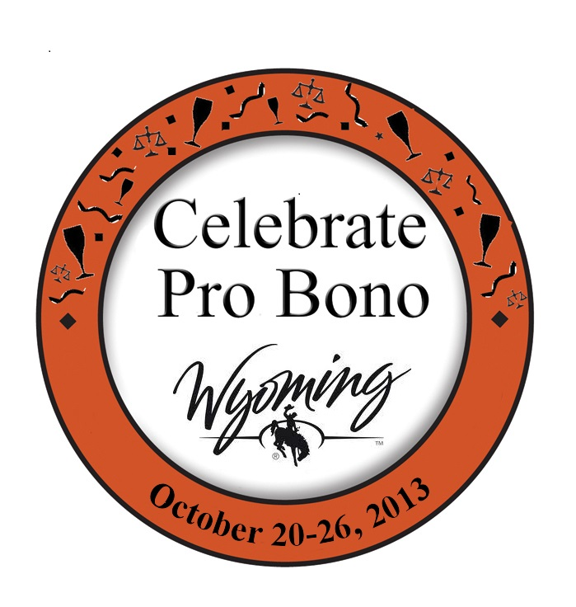

Sponsored by the

Sheridan County Bar Association