Pro Bono Day Legal Clinic

Saturday, October 19, 2013

9:00 a.m. to 12:00 p.m.

Wage Connection, DSS

975 Beards Hill Road, Aberdeen, MD 21001

Discuss your civil legal problems one on one at a legal clinic with volunteer attorneys!
No registration is required. Please bring any relevant documents/court paperwork with you.
For more information, call Desiree at 410-776-7949

➢ Landlord/Tenant

➢ Bankruptcy

➢ Foreclosure
➢ Family Law

➢ Criminal Expungement

➢ Wills and Advance Directives

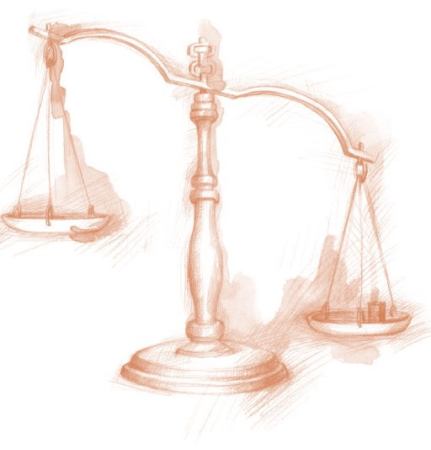

Sponsored by:

Harford County Pro Bono Committee
And
Maryland Legal Aid

